**Name – Aditya Sushil Bedve**

**Form no – 240500064**

**Centre Name - Kharghar**

**Part A**

• echo "Hello, World!" // print hello, world!

• name="Productive" //assign Productive to the variable name

• touch file.txt // crete empty file name

• ls -a // list out all file and directories

• rm file.txt // can remove file.txt

• cp file1.txt file2.txt //copy content of file1 to file2

• mv file.txt /path/to/directory/ // move file.txt to specific directory

• chmod 755 script.sh // give permission of script.sh to readable and executable by everyone but only writable by the owner

• grep "pattern" file.txt // search the string and return it also return all similar string

• kill PID // kill the process

• mkdir mydir (make dir of mydir )&& cd mydir(enter the mydir dir) && touch file.txt(create eempty file) && echo "Hello, World!" > file.txt (create file and writtened hello world)&& cat file.txt(show the data in written in file.txt)

• ls -l | grep ".txt" // list of directories in long format in txt format

• cat file1.txt file2.txt | sort | uniq // concat file1.txt and file2.txt and display only duplicate line

• ls -l | grep "^d" // list of directories in long format

• grep -r "pattern" /path/to/directory/ //recursively search for the string pattern in all file

• cat file1.txt file2.txt | sort | uniq –d // concat file1.txt and file2.txt then sorted combine output and remove duplicate

• chmod 644 file.txt // change the permission of file.txt tobe readable and writable by owner and reader by other

• cp -r source_directory destination_directory // copy recursively sorce dir to destination dir

• find /path/to/search -name "*.txt"

• chmod u+x file.txt // adds execute permission for the owner of file.txt

• echo $PATH // display current value of path in details

Part B – T/F

1. ls is used to list files and directories in a directory. // TRUE

2. mv is used to move files and directories. // TRUE

3. cd is used to copy files and directories. //FALSE

4. pwd stands for "print working directory" and displays the current directory. //TRUE

5. grep is used to search for patterns in files. //TRUE

6. chmod 755 file.txt gives read, write, and execute permissions to the owner, and read and execute

permissions to group and others. // TRUE

7. mkdir -p directory1/directory2 creates nested directories, creating directory2 inside directory1

if directory1 does not exist. // TRUE

8. rm -rf file.txt deletes a file forcefully without confirmation. //TRUE

**Identify the Incorrect Commands:**

1. chmodx is used to change file permissions. // chmod is use to change file permission

2. cpy is used to copy files and directories. // cp is use to copy file and dir

3. mkfile is used to create a new file. // mkfile is use to create specific file of specific size - b,k,m,g

4. catx is used to concatenate files. // cat is use to display data

5. rn is used to rename files. // rn use to remove files

PART C

Question 1: Write a shell script that prints "Hello, World!" to the terminal.

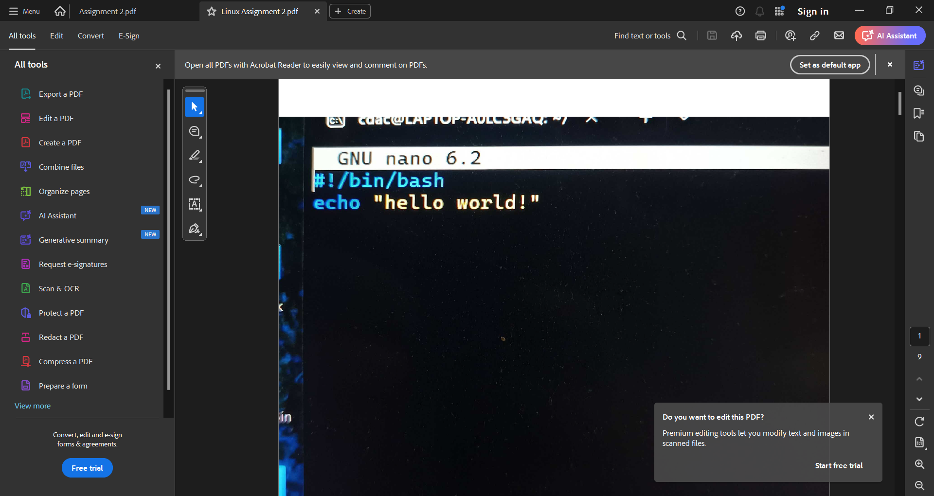

Question 2: Declare a variable named "name" and assign the value "CDAC Mumbai" to it. Print the

value of the variable.

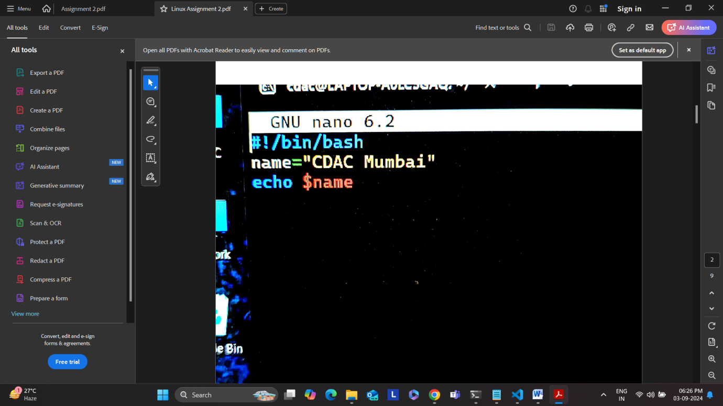

Question 3: Write a shell script that takes a number as input from the user and prints it.

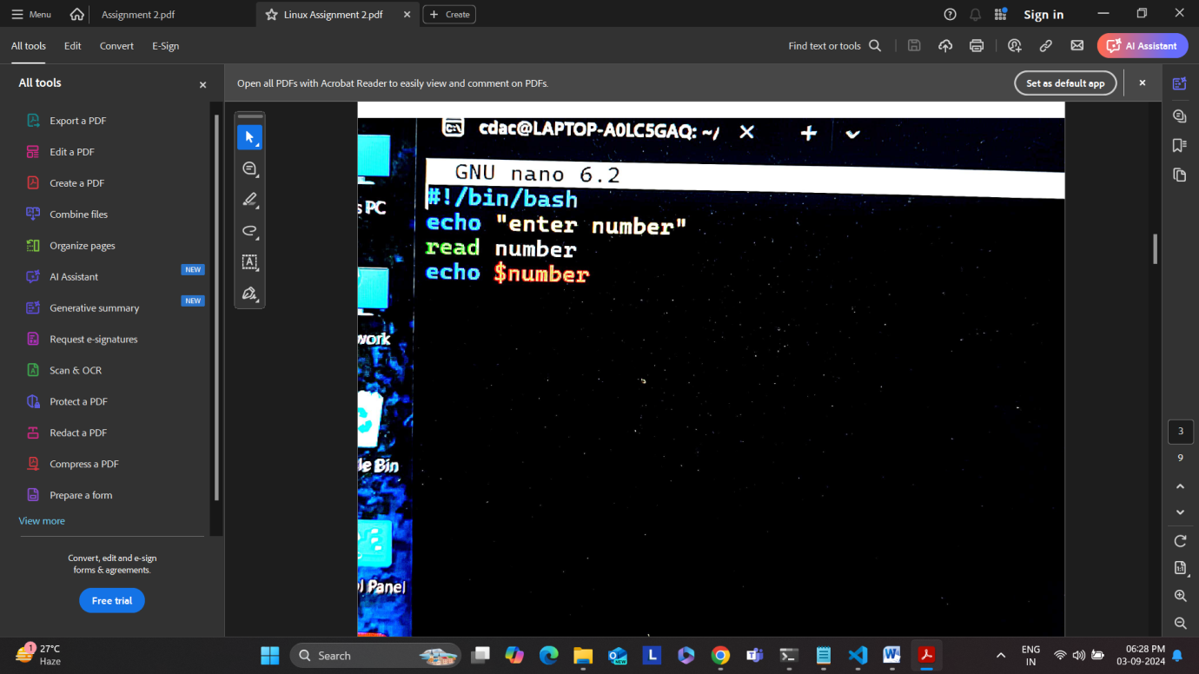

Question 4: Write a shell script that performs addition of two numbers (e.g., 5 and 3) and prints the results

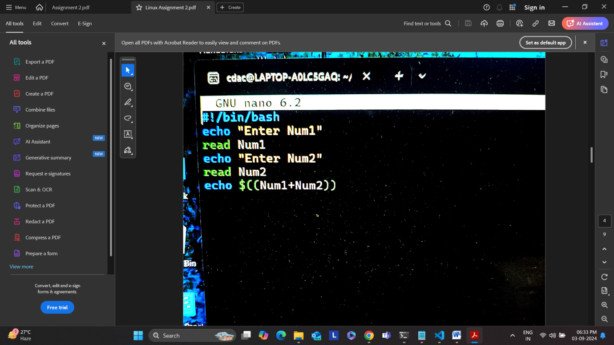

Question 5: Write a shell script that takes a number as input and prints "Even" if it is even, otherwise

prints "Odd".

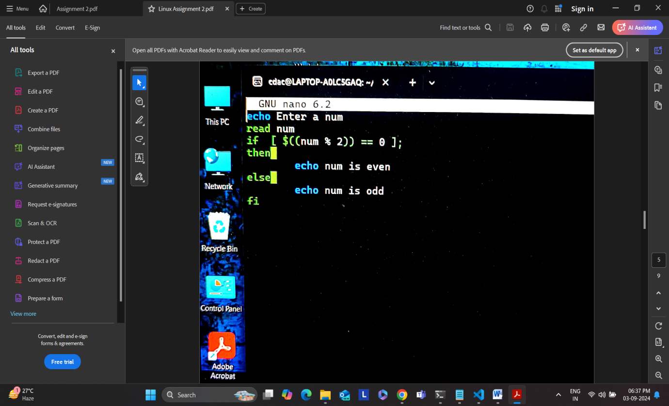

Question 6: Write a shell script that uses a for loop to print numbers from 1 to 5.

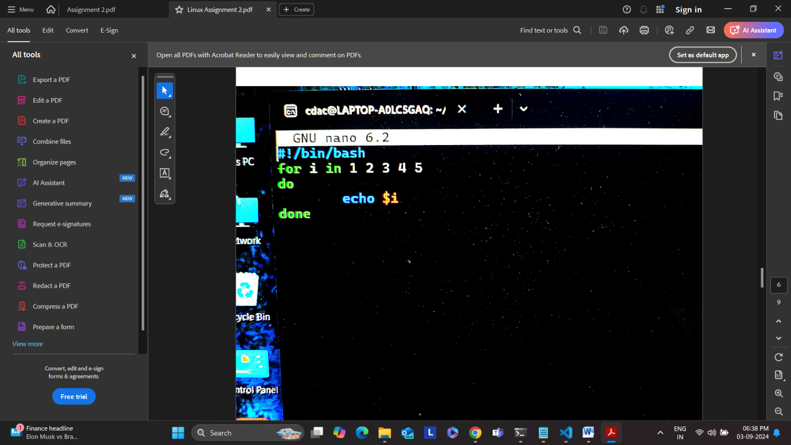

Question 7: Write a shell script that uses a while loop to print numbers from 1 to 5.

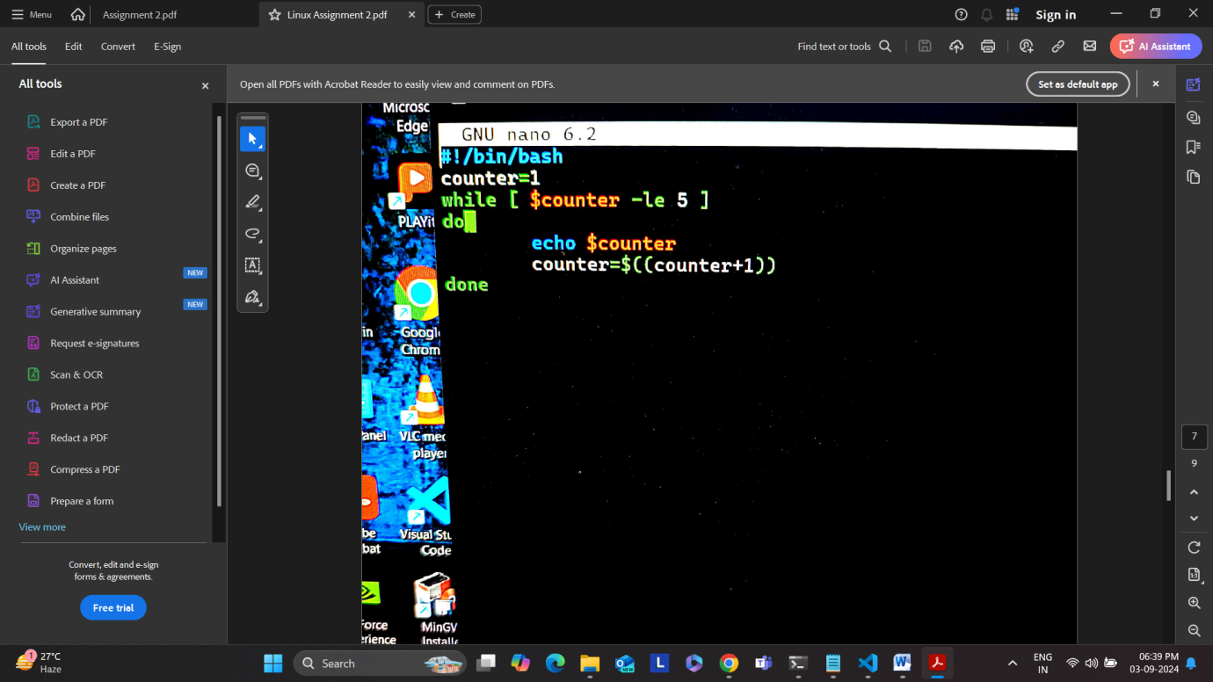

Question 8: Write a shell script that checks if a file named "file.txt" exists in the current directory. If it

does, print "File exists", otherwise, print "File does not exist".

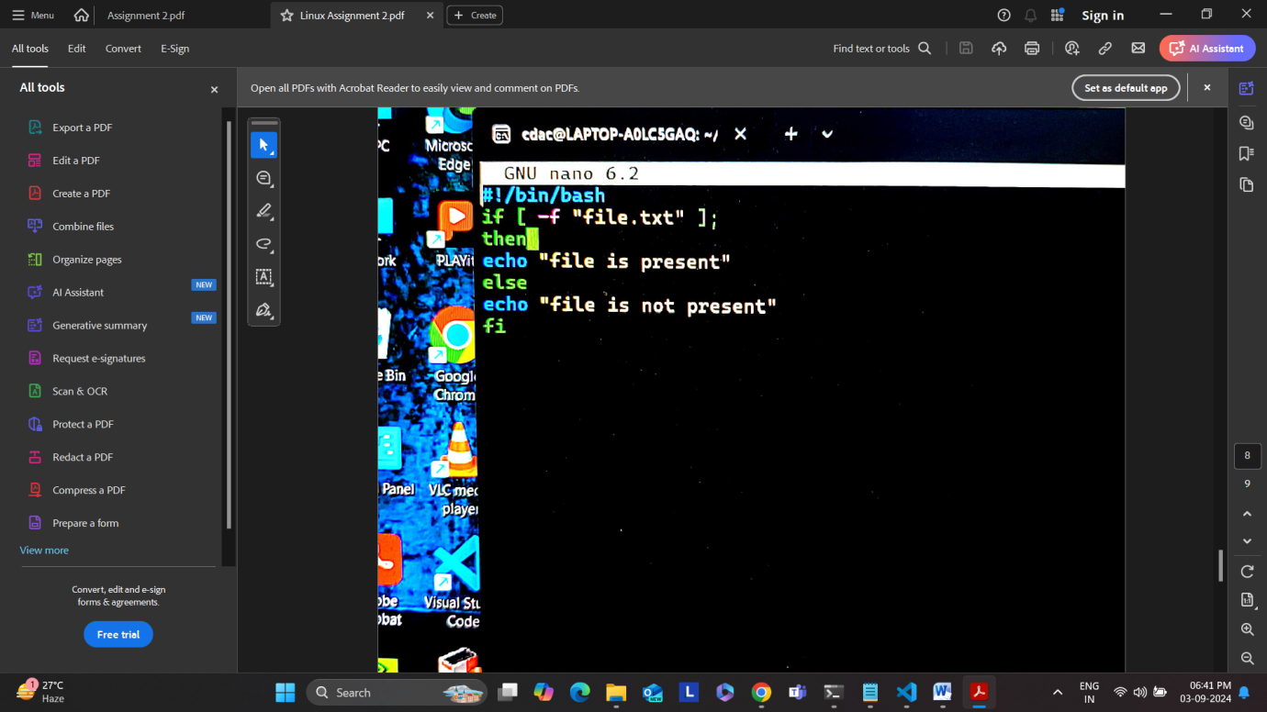

Question 9: Write a shell script that uses the if statement to check if a number is greater than 10 and

prints a message accordingly.

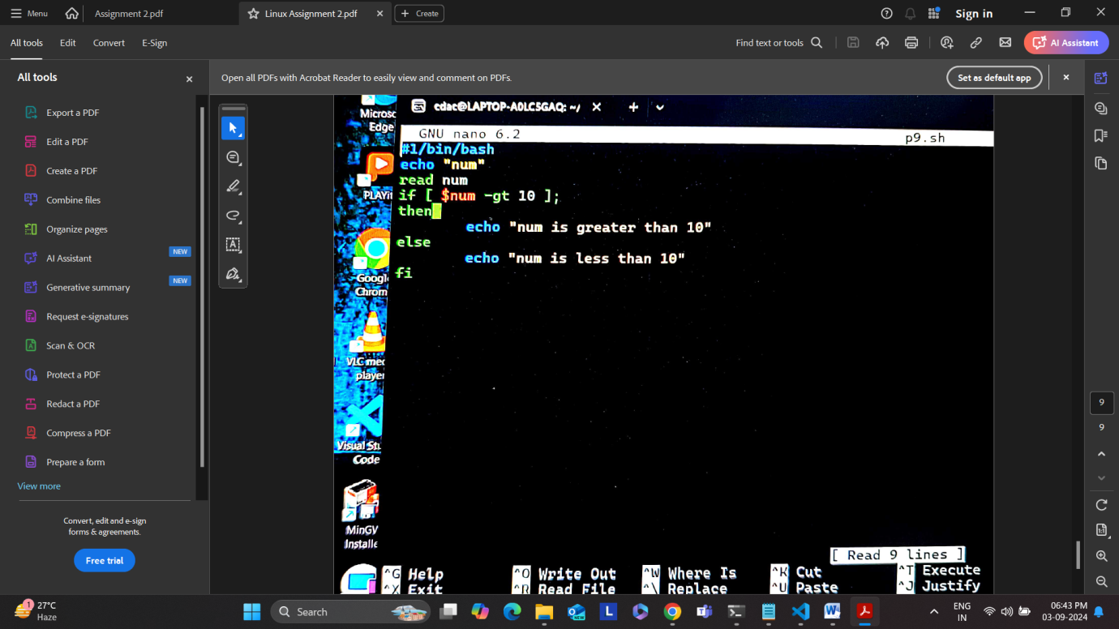

Question 10: Write a shell script that uses nested for loops to print a multiplication table for numbers

from 1 to 5. The output should be formatted nicely, with each row representing a number and each

column representing the multiplication result for that number.

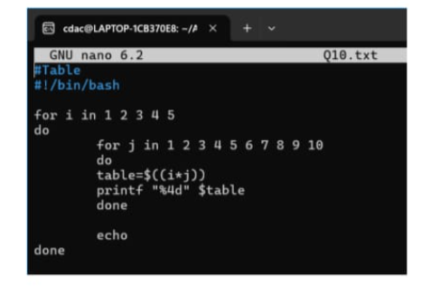

Question 11: Write a shell script that uses a while loop to read numbers from the user until the user enters

a negative number. For each positive number entered, print its square. Use the break statement to exit the

loop when a negative number is entered.

#!/bin/bash

echo "Enter number ( negative number to exit)"

while true

do

read num

if [ $num -lt 0 ]; then

break

fi

square=$((num * num))

echo " The square of $num is : $square"

done

echo "Exited loop"